# PowerBi Project: Madhav Ecommerce Sales Analysis:

**PROJECT OBJECTIVE:**

Owner of **Madhav Store** want us to help them create a **dashboard** to track and analyze their onlines sales across India

**DASHBOARD:**

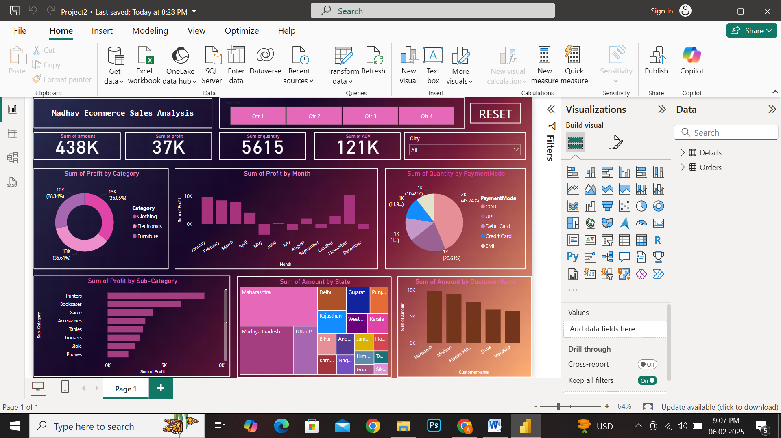

**PROJECT LEARNINGS:**

* Created interactive dashboard to track and analyze online sales data
* Use Complex parameters to drill down in worksheet and customization using **Filters** and **Slicers**
* Created connections , join new tables, calculation to manipulate data and enable user driven parameters for visualization
* Use different type of customized Visualization(Bar chart, pie chart, donut chart, slicers, cards)